2026 Taichung International Dance Carnival
Street Fun Dance Competition Registration Guidelines
2026.7.17
Since 2016, the "Taichung International Dance Carnival" has brought together diverse dance styles from around the world and integrated local cultural elements to showcase the passion and vitality of Taichung. In the spirit of "Dance for All, Join the Movement, " we invite all dance enthusiasts to form teams and sign up. The streets are your stage—come and dance with us!
The 2026 Taichung International Dance Carnival will be held from September 12 (Saturday) to September 13 (Sunday). This event will be held consecutively in Houli District, Tanzi District, North District and Beitun District of Taichung City for the first time. For detailed event procedures, please check the Taichung City Government Tourism and Travel Bureau website.
Join street fun dance competition on September 12 (Saturday) and September 13 (Sunday)! All dance styles are welcome, and prizes worth up to NT$200,000! And this year brings an exciting new highlight: the first-place teams from both sessions will be invited to perform on the main stage! Online registration is now open. Join us this autumn and experience the excitement of turning the streets into a dance stage in Taichung!

【Organizers】
- Guided by: Tourism Administration, MOTC; Taichung City Government
- Organized by: Taichung City Government Tourism and Travel Bureau
- Executed by: Wheat Art Integrated Marketing Co., Lt

【Event Time】
- September 12,2026(Sat.) ,14:30 – 16:30
- September 13,2026(Sun.),14:30 – 16:30
Note: The event may begin earlier depending on the number of registered teams.

【Location】
- Tanzi Session : September 12,2026(Sat.)
Shengli Road (from the intersection of the third section of Tanxing Road to the side gate of Tan Show Junior High School).

- Beitun Session : September 13,2026(Sun.)
Fengle 3rd Street to Section 2 of Fengle Road (side gate of Ssu Chang Li Junior High School to Sizhangli Park).
【Eligibility】
- Minimum of 10 members per team.
- No age or background restrictions.
- Each team can register for 2 events in Tanzi District and Beitun District at the same time, and there is no limit to the dance code.
- Duplicate registration by any individual is not allowed.

【How To Register】
- Online Registration
- Period: From now until August 21, 2026 (Friday) at 23:59.
- How to register (choose one):
- Fill in the Google From(https://reurl.cc/dpoNmM)
- Complete the attached form and email it to the official email (weiz00883@gmail.com)
- Music Submission: Submit your MP3 music file by August 31, 2026 (Monday).
Street performance music is limited to 90 seconds, and the main stage performance music is limited to 210 seconds.
- Competition Order: Based on registration time. The earlier you register, the earlier your team performs.
- Check-in Time on Event Day: From 12:30 to 14:00 on the event day.
- September 12,2026(Sat.): Outside Tanzi Sports Park (near Shengli Road)
- September 13,2026(Sun.): Entrance to Sizhangli Park (near Fengle Road)
Please refer to Diagram 1. Late arrivals will forfeit their eligibility.
- On-Site Registration
- Date & Time: Sep.12 (Sat.) and Sep.13 (Sun.), 12:30 – 14:00.
- Location: Official check-in area (Diagram 1 – The Red Point).
- Requirements: Bring the completed form and music file (MP3)
Street performance music is limited to 90 seconds, and the main stage performance music is limited to 210 seconds.
- Performance Order: After all online registrants, in the order of on-site sign-up.
Official check-in area

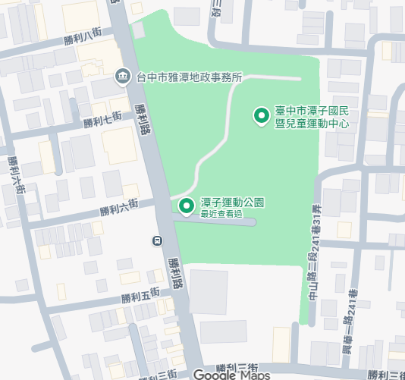
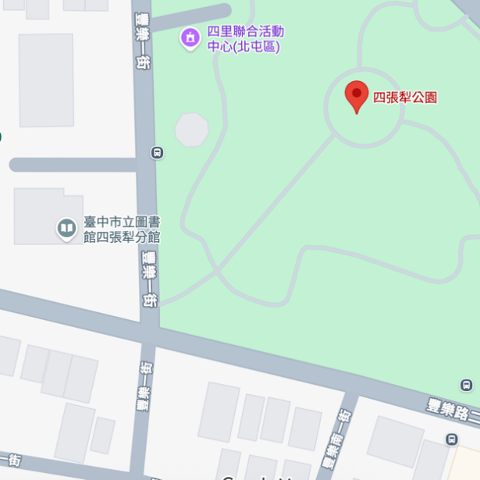
Fengle 1st street
Tanzi Sports Park

Shengli Road
Sep.12
Tanzi
Session
Sep.13
Fengle 2nd Road
Beitun
Session

【Event Rules】
- Teams must check in between 12:30－14:00 on Sep.12 and Sep.13.
- Scan the on-site QR code to read Pre-Event instruction.
- Please join the event-related information session on 14:00 to 14:30 on official check-in area.
- Participating teams are requested to pay close attention to the scheduled timelines. Teams that fail to respond when called and cannot be reached by phone after the designated time will be deemed to have forfeited their eligibility.
- The event is divided into two days and two areas. The following will describe the fun competition performance routes and formats separately:
- Tanzi District :
- Starting Point : Intersection of Shengli Road and Tanxing Third Street, Tanzi District.
Terminal line: Shengli Road, Tanzi District (at the entrance of Lijiao Industrial Co., Ltd.), approximately 360 meters long (route shown in the diagram below).
- This event has two designated performance areas. The viewing platform is the second designated area (as shown in the diagram below). Teams should perform at their designated areas in sequence. The first designated performance area is near Victory 11th Street (outside the Young Man's Glasses booth); the second designated performance area is the viewing platform (outside the bus stop bend, outside the Kid Castle English School).
- After completing the first designated performance area, please continue in a street-walking style (walking and jumping) to the viewing platform for the final designated performance. Please do not remain stationary for extended periods.
- Each performance is limited to 90 seconds. After finishing, teams shall proceed to the finish point and return to the rest area under staff direction.

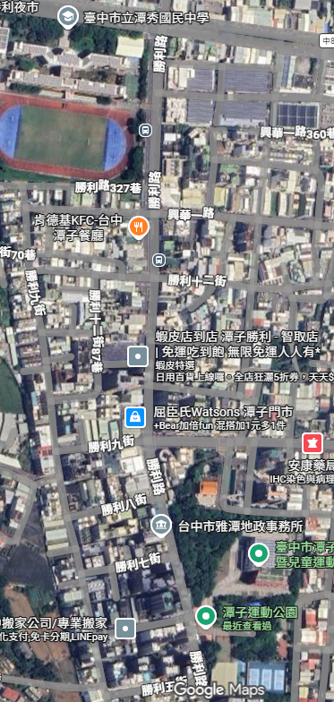
Terminal point
★
Check in area

Group assembly area

Viewing platform
★
Parade Section

★ Performance Zone

starting point

- Beitun District :
- Starting Point :
Intersection of Section 2 and Fengle 3rd Street, Beitun District
Terminal point:
Intersection of Section 2 and Fengle 1st Street, Beitun District, with a total length of about 230 meters.
- This event has two designated performance areas: the first is the viewing platform (in front of the viewing platform at the intersection); the second one is located along the road in front of the National Taxation Bureau and the Post Office.
- The viewing platform is the first designated area (as shown in the diagram below). After your performance, please proceed to the second designated area in a street-walking style (walking and jumping) for your performance. Each performance time is a maximum of 90 seconds; please do not remain stationary for extended periods during this time.
- Each performance is limited to 90 seconds. After finishing, teams shall proceed to the finish point and return to the rest area under staff direction.

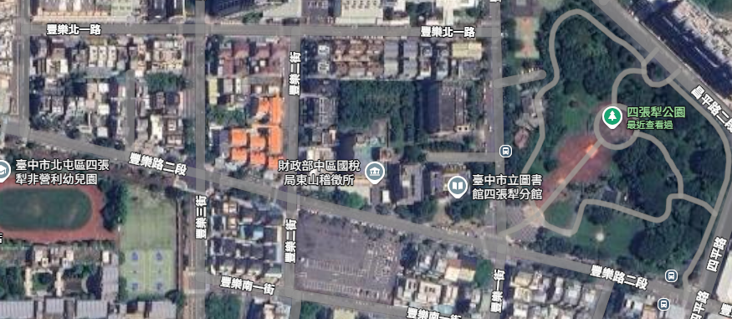
★ Performance Zone
Parade Section
Viewing platform
Group assembly area
Check in area
★
★
starting point
Terminal point

- Costumes and music must be self-prepared. Do not bring valuables to the event area.
- This event is an annual celebration that brings together outstanding performers from all walks of life. The venue’s road closures, traffic arrangements, and performance schedule are the result of extensive planning and coordination. The event will proceed as scheduled, rain or shine. In case of rainy days, the organizer will provide hair dryers and hot water for performers to use.
【Judging Criteria】
Judging include youth committee members and professionals. Scoring includes:
- Parade Performance – 35%
- Stationary Performance – 30%
- Teamwork– 20%
- Costume/Character Appeal -15%

- To ensure the smooth progress of the event, participants are reminded to control the pace and duration of their performance. Exceeding the allotted time may result in point deductions.
- In case of a tie, the candidate with the higher score in Parade Performance will be given priority.
【Awards & Prizes】
All participating teams are eligible for the following awards:
- First Place:1 team per session, prize NT$30,000.
- Second Place: 1 team per session, prize NT$20,000.
- Third Place: 1 team per session, prize NT$15,000.
- Excellence Awards: 7 teams per session, prize NT$5,000 each.
- The first-place team from each session will be invited to give an honorary performance on the event’s main stage on the same day, showcasing their team spirit, unique style, and finest performance.
(Tanzi Session: Tan Show Junior High School / Beitun Session: Sizhangli Park)
【Evaluation Results】
- September 12,2026(Sat.)
The results will be announced that evening at the Tan Show Junior High School main stage event and simultaneously posted in the official Line group for the All-People Dance Contest. Participating teams are requested to arrive at the designated meeting point next to the Tan Show Junior High School main stage before 18:00 on the day of the event, and be prepared for the awards ceremony and group photo. Teams that fail to arrive after three attempts to contact them will be disqualified.

- September 13,2026(Sun.)
The results will be announced that evening at the Sizhangli Park main stage event and simultaneously posted in the official Line group for the All-People Dance Contest. Participating teams are requested to arrive at the designated meeting point next to the Sizhangli Park main stage before 18:00 on the day of the event, and be prepared for the awards ceremony and group photo. Teams that fail to arrive after three attempts to contact them will be disqualified.
【Notes for Participants】
- Judges reserve the right to withhold awards if performance doesn’t meet standards.
- Registration information must be truthful and complete.
- Participants may not register with multiple teams.
- Participants must report and perform at the designated time on the day of the event. Failure to check in on time will result in point deductions. If there is no response after three calls, the participant will be disqualified automatically.
- Performers are responsible for costumes, props, and music.
- All music and performances must comply with copyright laws. In the event of any infringement or improper citation, the participant shall assume full legal responsibility, and the organizer reserves the right to disqualify the participant and take further legal action if necessary.
- Dangerous props (e.g., paint, fire, weapons) are prohibited.
- No gift-giving or sales during performances
- Participants agree to allow the organizer to use personal information for event-related purposes.
- The organizer may record or film the event and use materials for promotion without additional consent.
- The organizer reserves the right to interpret, revise, or cancel the event. Any changes will be announced on the Taichung Tourism website.
- According to Taiwan tax law, prizes exceeding NT$1,000 are subject to income tax declaration.
- All participants in this event shall be deemed to have agreed to all of the above regulations.

【Contact Information】
Tel: +886- 988-819-308 Mr. Cheng (Monday to Friday, 10:00 – 17:00)

2026 Taichung International Dance Carnival
Please select:
□ Tanzi Session
□ Beitun Session
□ Both Sessions

Street Fun Dance Competition Registration Form
Team Name |  |  | Number  of Performers  (minimum 10) |  | Team  Number | (To be filled by organizer)  NO. __________
Main  Contact | １. | Contact Phone Number  (reachable on the event day) |  | 1.
Main  Contact | 2. |  |  | 2.
Address
Team Introduction：
Performance Description：
□I am fully aware that costumes, props, and music must be provided by the team and must comply with copyright and all relevant laws.
□I hereby confirm that I have read and agree to abide by all the terms outlined in the "2026 Taichung International Dance Carnival –Street Fun Dance Competition Registration Guidelines."
Signature of Registrant:：

If participating teams require a certificate of participation, please contact Mr. Cheng (+886-988819308) before Sep. 20, 2026, and provide information such as the team name and the names of team members.

